OOJ LAB RECORD PROGRAM 6-8

BY

S.R.POOJA 1BM19CS135

6.Create a package CIE which has two classes- Student and Internals. The class Personal has members like usn,name,sem. The class Internals has an array that stores the internal marks scored in five courses of the current semester of the student. Create another package SEE which has the class External which is derived class of Student. This class has an array that stores the SEE marks scored in five courses of the current semester of the student. Import the two packages in a file that declares the final marks of n students in all five courses.

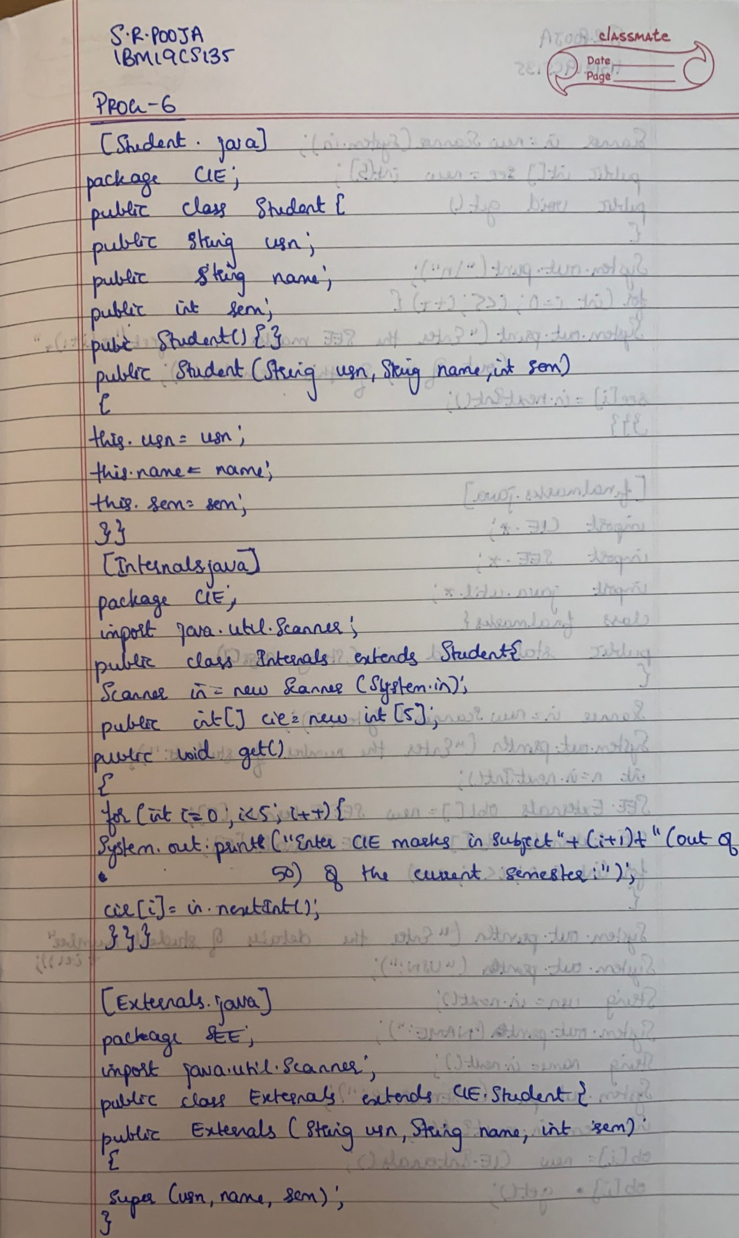

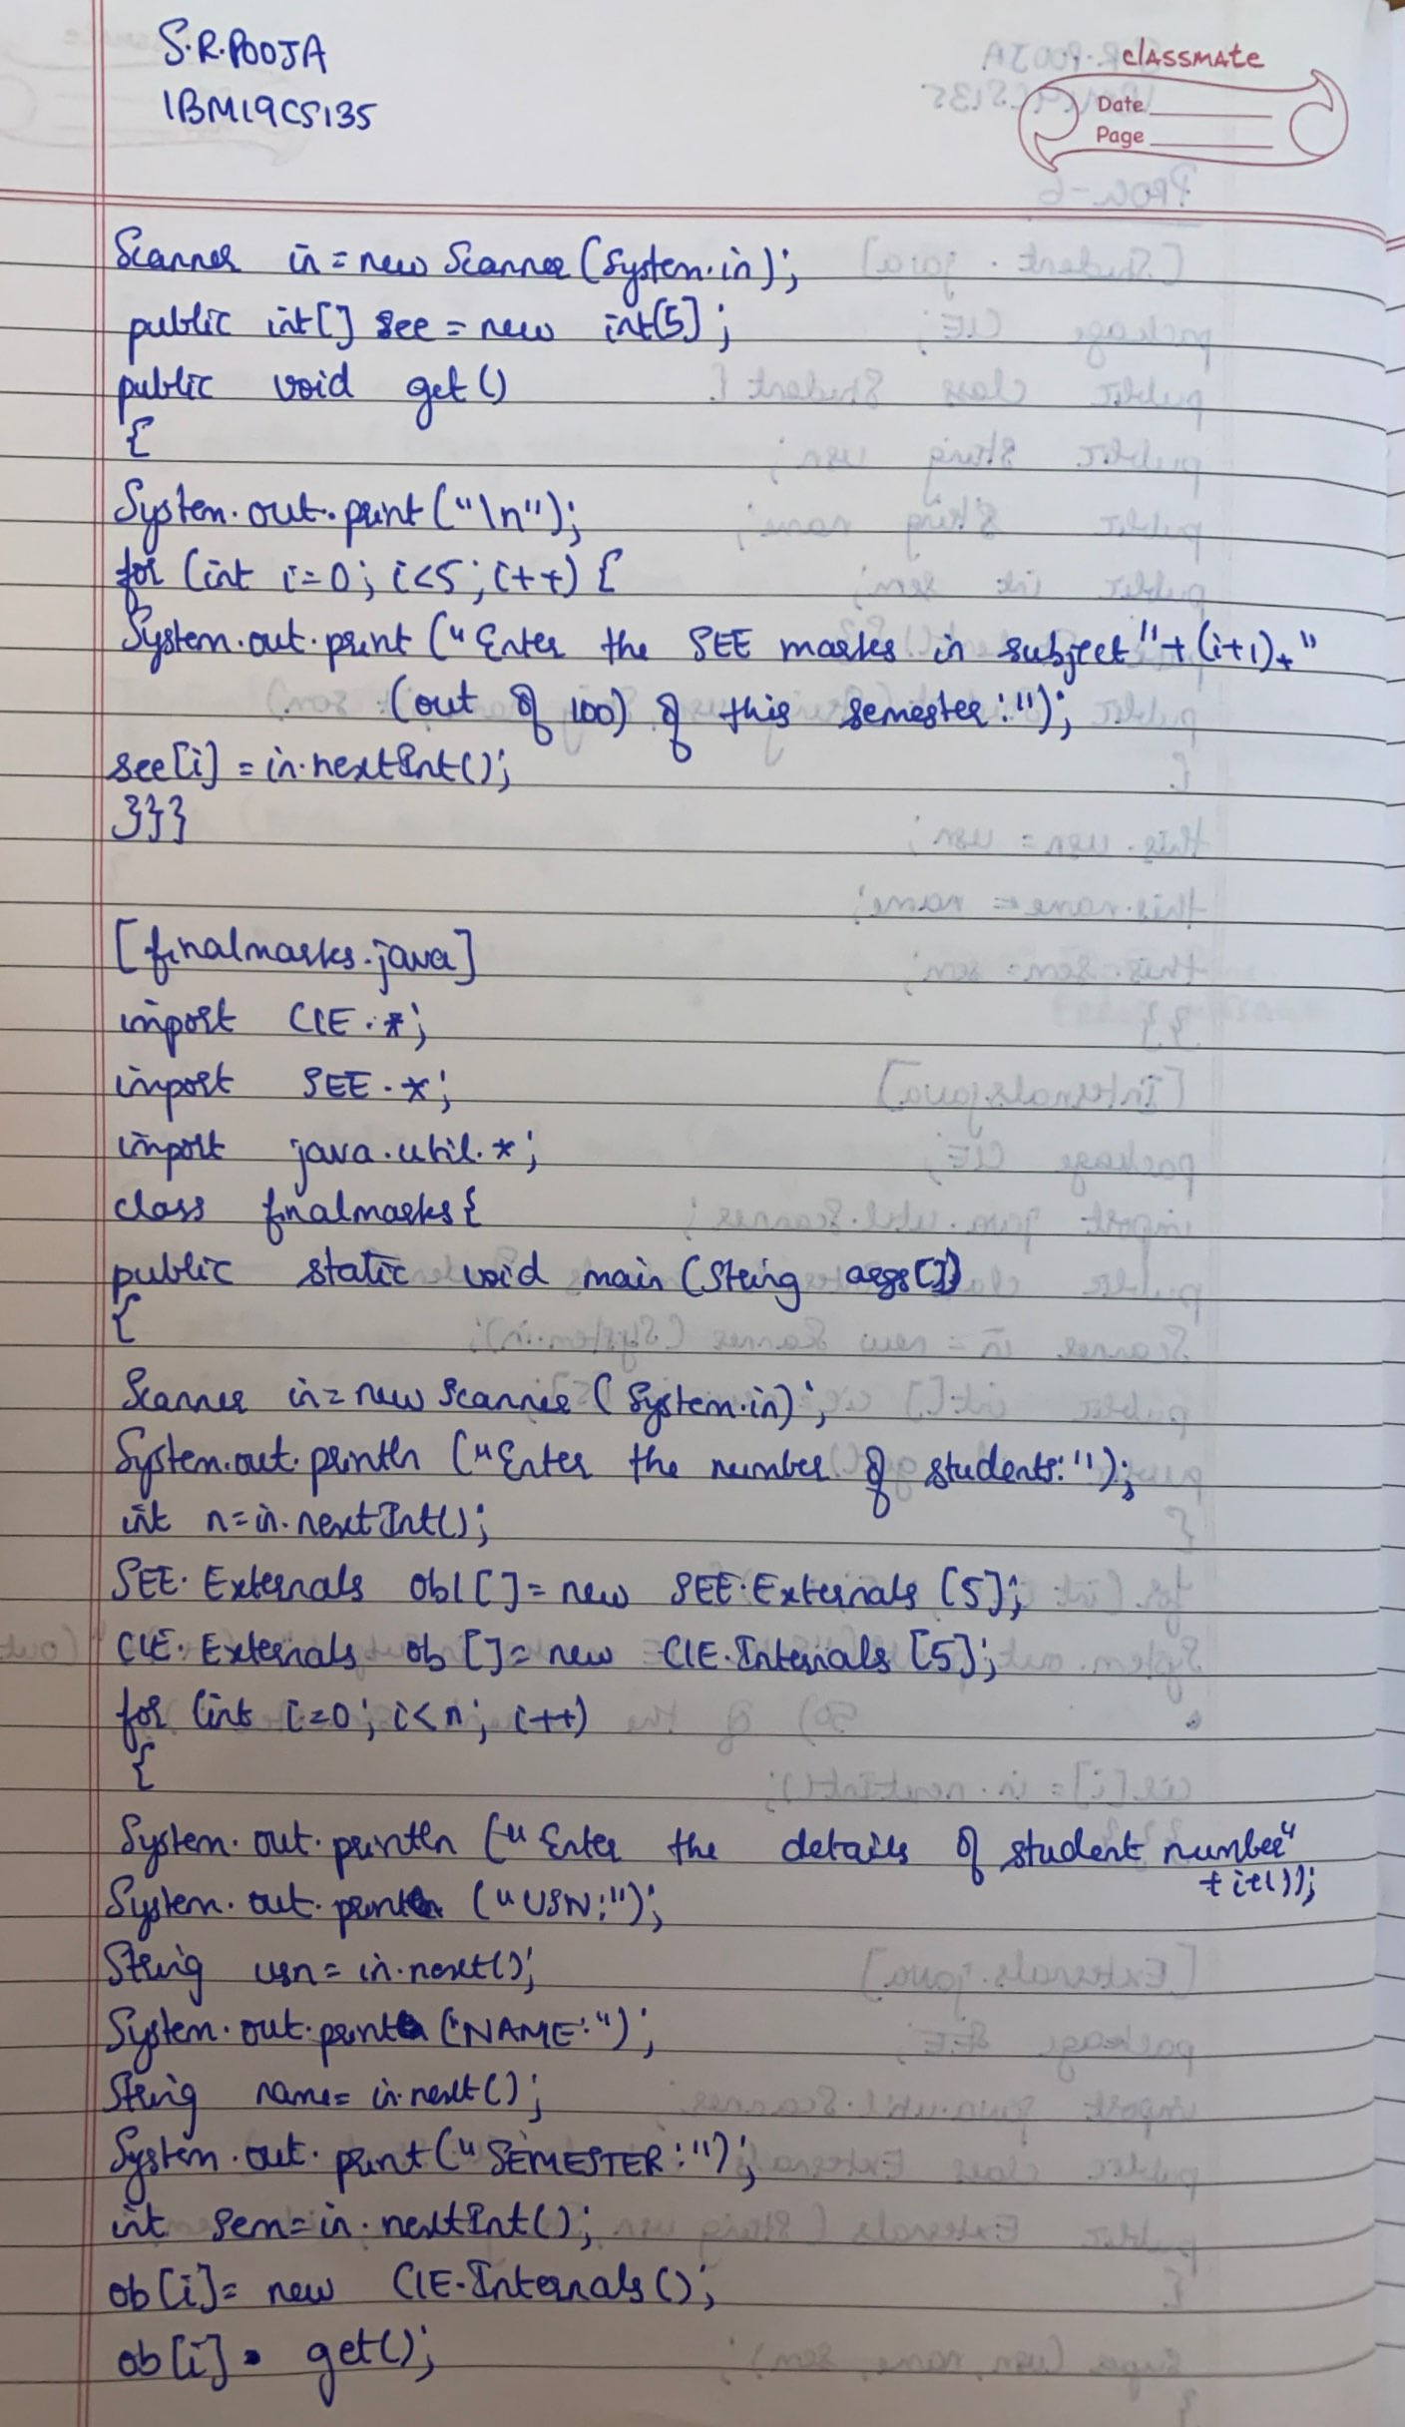

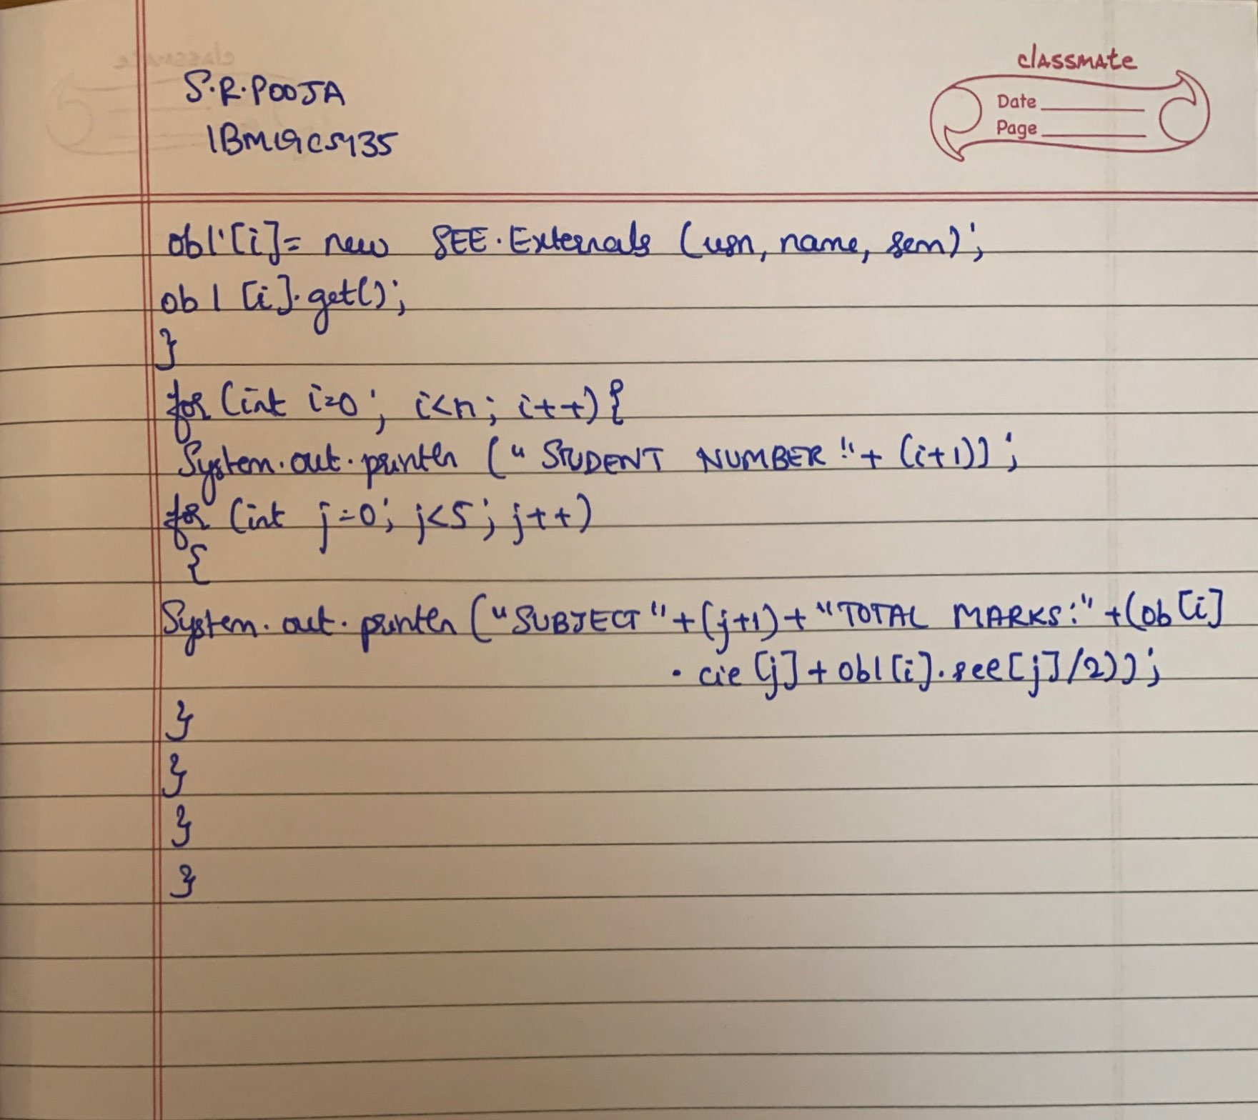

7.Write a program to demonstrate generics with multiple object parameters.

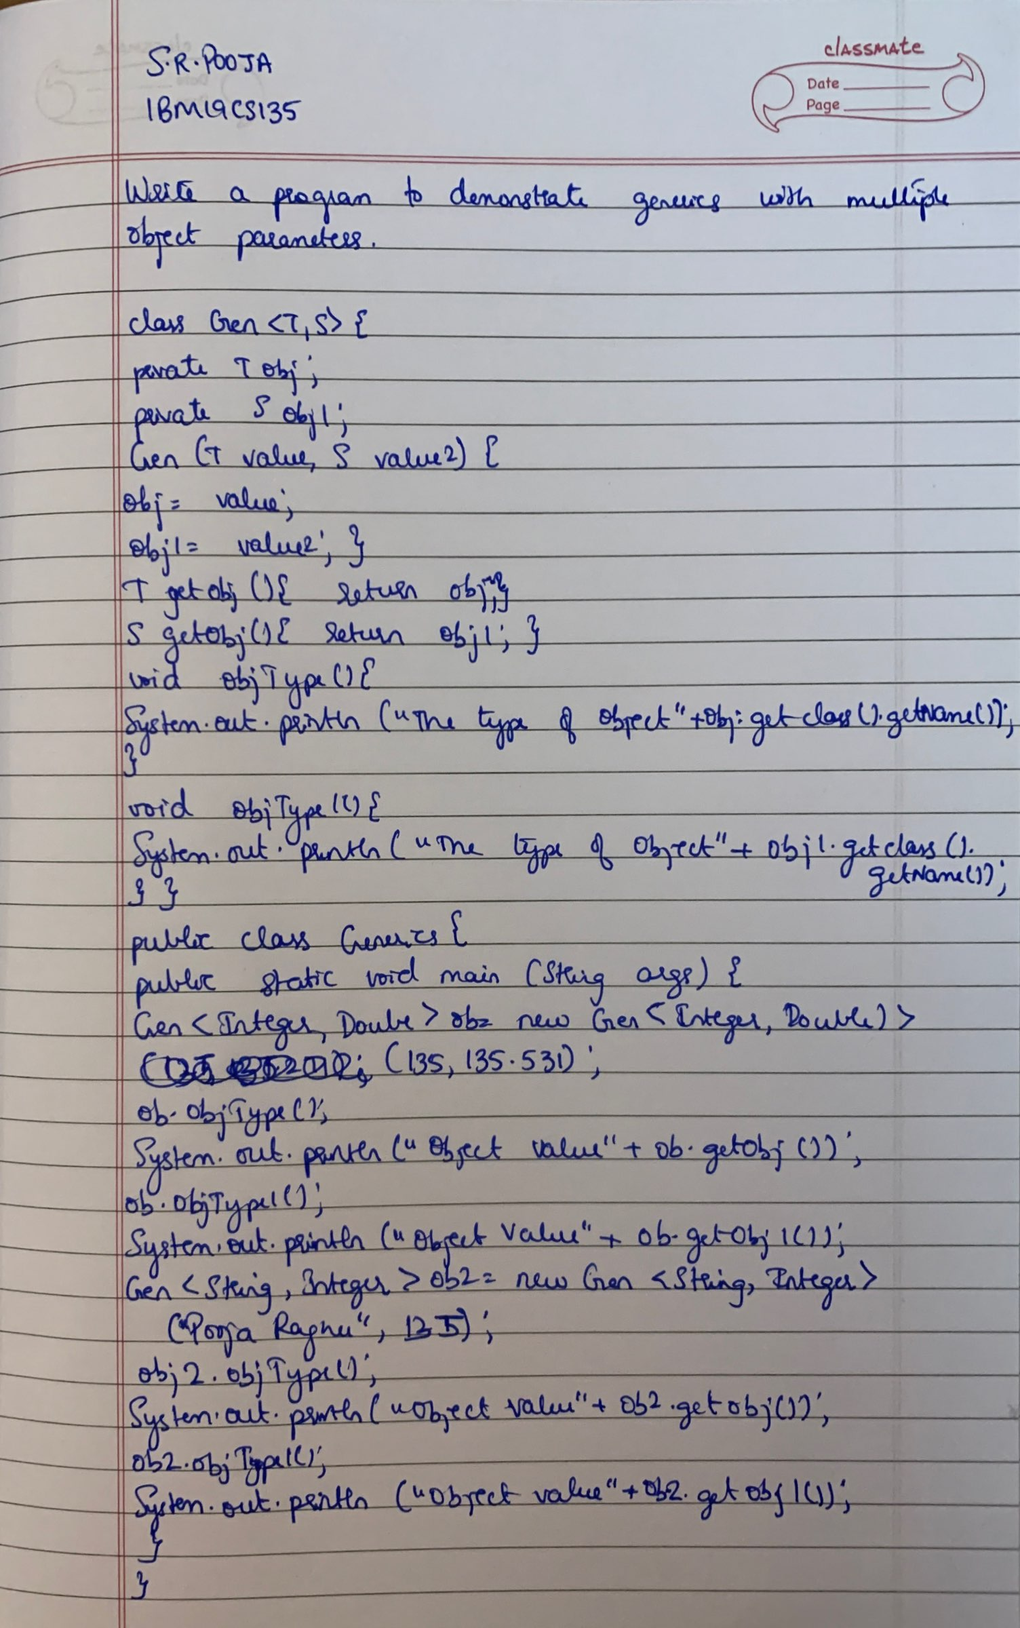

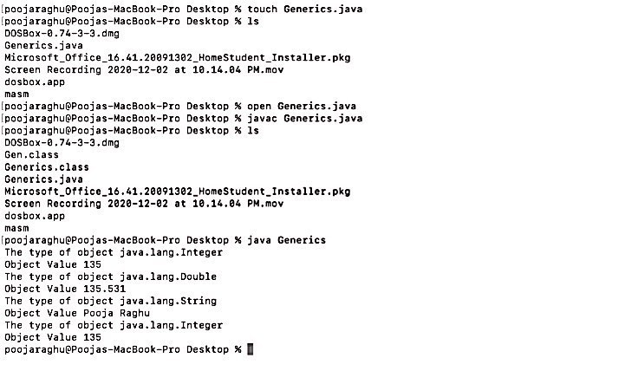

8. Write a program that demonstrates handling of exception in inheritance tree. Create a base class called “Father” and derived class called “Son” which extends the base class. In Father class, implement a constructor which takes the age and throws the exception WrongAge() when the input age<0. In Son class, implement a contructor that cases both father and son’s age and throws an exception if the son’s age is >= father’s age.

